Coastal Plain Talk of the South Hampton Roads Chapter: VNPS November 2014
Wednesday, November 12th- 56th Annual Garden Club of Virginia Conservation Forum: "Trees: Virginia's Remarkable, Renewable Resource" at the Ted Constant Convocation Center, Old Dominion University, 4320 Hampton Blvd, Norfolk, VA 23529. 8:30 AM-1PM. Information. Contact Ann Heller, Garden Club of Virginia at 804-643-4137or communications@gcvirginia.org
Thursday, November 20th – Helen Kuhns from Hoffler Creek Wildlife Foundation will give us a slideshow presentation on Hoffler Creek Park and their current projects. We meet at 7 PM in the Holly Room at the Norfolk Botanical Garden.
Friends of Indian River will have a regular meeting on Thursday, November 13th, 7 pm, at the Oaklette United Methodist Church. Casey Shaw from the Elizabeth River Project will be talking to us about the brand new Restoration Plan for our Eastern Branch, including the Indian River. Come out and learn about the planned efforts including improved public access to the river, trails, River Star Home opportunities and more. There will be light refreshments and door prizes after the presentation. They will also be collecting donations for the Oaklette United Methodist Church food bank at this meeting. Just bring non-perishable goods to the meeting to help those less fortunate.
The following Saturday, November 15th, at 9:30 am Friends of Indian River will be doing a cleanup along Indian River Road, meeting at the Post Office. We'll be cleaning up 1 mile of Indian River Road from the city limits at Wingfield Avenue all the way to MacDonald Road. This will help to spruce up the area, collect trash that will otherwise get washed into the river and impact wildlife, and give us the opportunity to interact with residents and businesses along Indian River Road. We're looking for a good turnout for this volunteer event, so please come out.
Thursday, December 4th- Gathering of the Gardeners Potluck Dinner from 6-9 PM at the Norfolk Botanical Garden. Bring something to share and join the other organizations that meet at and support the garden. After dinner, we will be able to drive through the Garden of Lights. Please RSVP to Kathleen Stasulis: 757-486-5485 or stasulisss@hotmail.com by November 26th.
Thursday, January 22nd- Glenn Butler, ISA Certified Master Arborist of Streamline Tree Care will speak to us on Native Trees and how important they are to the survival of wildlife.
Friday - Sunday, January 31st – February 2nd, 2015 – Flower & Garden Expo 2015: Curb Appeal: It’s Out Front That Counts We will have a double booth as usual and everyone is welcome to participate with the booth or stand in the booth to greet and answer questions. We always have two to three people per shift to handle the crowds and their many questions about native plants. This is a great opportunity to learn yourself what natives can do to improve your landscape! Signups will be at the next meeting.
Thursday, February 26th – Carol Heiser, Habitat Educational Coordinator with the Virginia Department of Games & Inland Fisheries will speak to us on current projects being developed using native plants. Our meeting begins at 7 PM.
President’s Message: The South Hampton Roads Chapter played host to the 2014 State Virginia Native Plant Annual Meeting. The event was at the Virginia Beach Resort Hotel & Conference Center. We had tours to many of our local parks and gardens, including First Landing State Park, False Cape, Northwest River Park, Norfolk Hermitage Museum & Gardens, Norfolk Botanical Garden, Dismal Swamp, Pleasurehouse Point and many other locations. Our participants had a blast and the weather was perfect for the weekend festivities! Steve, Kathleen and Brenda pulled off this conference with many hours of hard work. Thanks so much for all that you did to make this a worthwhile event for our members.
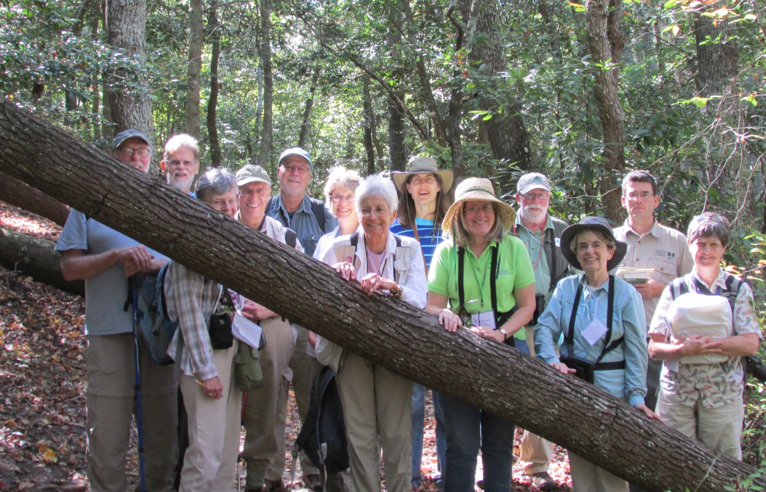
From left to right: Richard Cooper (Sally's husband), Cliff Gay, Ginny and Bob Yacovissi, Kurt Hess, Sherrie Burson, Shirley Gay, Brenda Skarphol, Nancy Vehrs, Harry Glasgow, Harriet Hess, and trip co-leader, Sally Anderson. Beth Richardson took the picture of the Saturday field trip to First Landing Park.
Some members went on the annual Canoe Trip on Muddy Creek with Byron as our tour guide and host. Pictures can be viewed at https://www.dropbox.com/sh/pa0zb03abq961gb/AAB6GhJPeI4gkWbpyL0SPQCda?dl=0
Our order for the Plant Invaders of Mid-Atlantic Natural Areas books came in which we will sell this book for $5.00 at our future community booth. Please visit our website at http://www.vnps.org for additional details and further references for your interests. Wild about native plants! Beth
Upcoming dates:
Saturday, April 4, 2015 will be the Native Plant Sale at the Frances Land House during the Gathering of the Guilds Celebration.
Saturday, May 9-10, 2015 will be the Native Plant Sale at the Norfolk Botanical Garden. Save the date!

