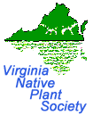 Coastal Plain Talk

Newsletter of the South Hampton Roads Chapter____________ _March/April 2014

Calendar of Events
Additional details online at www.sites/google.com/site/vanativeplantsociety/

Thursday, March 27th- Dr. Chris Ludwig Training on the Flora of Virginia at 7 PM in the TBA at the Norfolk Botanical Garden.

Saturday, April 5th - SHRC-VNPS Plant Sale from 9 AM – 3 PM in conjunction with the Butterfly Society’s Plant Sale from 9AM – 12 Noon. Please join us at the Francis Land House for the Gathering of the Guilds. This is a great family outing! 3131 Virginia Beach Blvd., Virginia Beach. No charge for admission.

Friday, Saturday, April 20th & 21st – Hermitage Museum and Gardens Spring Plant Sale. Friday from 10 AM – 3 PM & Saturday 9 AM to 2 PM. 7637 North Shore Road, Norfolk. Some native plants will be available, including those for wetlands. Contact Yolima Carr at yc@thfm.org or (757) 423-2052 ext. 202 for information.

Thursday, April 24th- SHRC-VNPS Chapter Meeting, 7 PM in the Holly Room at Norfolk Botanical Garden. TBA.

Friday & Saturday April 25th & 26th - Chesapeake Master Gardener Plant Sale, 8 AM to 6 PM, Friday, 9 AM to NOON Saturday. Located in front of the Great Bridge Community Center. 212 Holt Dr., Chesapeake. For more information, contact the Chesapeake Extension Office at (757) 382-6348.

Friday, Saturday, May 10 & 11- SHRC VNPS PLANT SALE, 10:00 a.m. – 4:00 p.m., at the Norfolk Botanical Garden in conjunction with the Mother’s Day Weekend Event. 6700 Azalea Garden Road, Norfolk. Regular NBG admission rates apply to enter the garden.

President’s Message:

We have a busy next couple months coming up, and, it's already time for planning of the plant sale which we started in December. Tyco is cutting blinds for labels. Some orders will be placed and some nursery visits are in store for the rest.

Saturdays: January 18th, February 8th & March 8th: Pre-Plant Sales Committee Meetings

Plant sale prep needs to be done ahead of our annual plant sales. We need to make labels, stick the labels to blind tags already cut by Tyco for us. Any plugs or seedlings that need to be transplanted into pots will be done also. Once we have plants in the greenhouse then the plants will have to be watered regularly. This meeting will be a good opportunity to review what worked well at our last plant sale and discuss any adjustments that can be made to improve the experience for everyone. If you cannot make this meeting but would like to volunteer for the sale(s), please contact Pat Quinn at pat.quinn@cox.net or at 757-587-8935.

Gardens Galore: Natives Galore
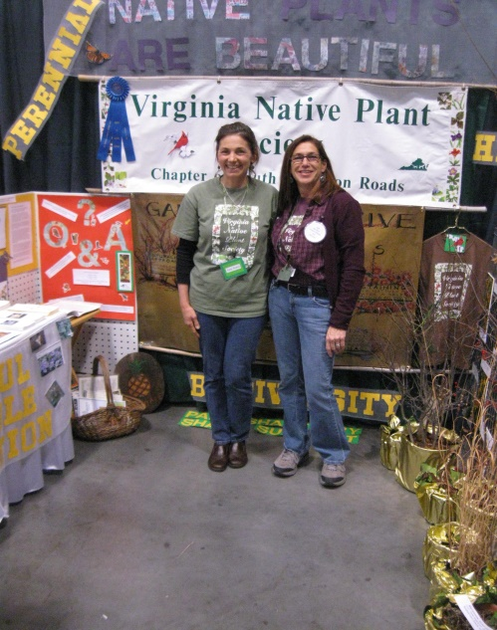
The Flower & Garden Expo 2014 is January 31 – February 2, 2014 at the Virginia Beach Convention Center. That is also Superbowl Weekend football fans so please make time for both shows!

We are requesting volunteers to work the booth in three hour shifts so we can cover our time from 10 AM to 7 PM on Friday and Saturday from 10 AM to 7 PM

We need volunteers on Sunday, Feb. 2nd from 10 AM to 5 PM. If you are interested in helping us set up, work a booth shift or tear down, please contact Amy Jones at or Beth Richardson at 757-574-5448.

Our Wildflower of the Year is

We will have a double booth with sample plants and hopefully the Flora of Virginia display. Come out and join the fun!

Saturday, April 6, 2014  10AM – 4PM  Francis Land House  In conjunction with  Gathering of the Guilds  3131 Virginia Beach Blvd  Virginia Beach, VA | Friday & Saturday  May 10 & 11, 2014  10AM – 5PM  Norfolk Botanical Garden  In conjunction with  Mother’s Day Weekend Event  6700 Azalea Garden Road  Norfolk, VA  (Regular NBG admission rates apply)
Plant sale proceeds fund the many conservation, restoration
and educational projects that the SHRC-VNPS supports.

Virginia Native Plant Society

South Hampton Roads Chapter
705 Elderberry Court
Chesapeake, VA 23320

