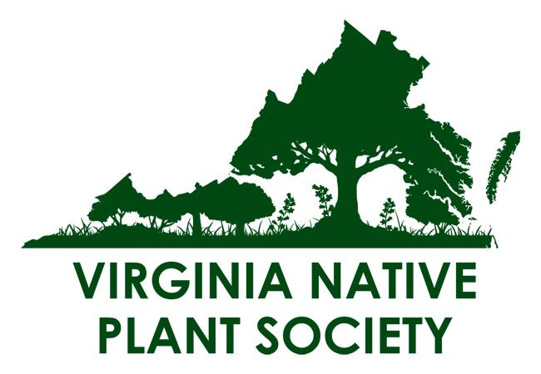
Virginia Native Plant Society
Quarterly Board of Directors (BOD) Meeting
Wednesday, September 10, 2025, 7 p.m.
Zoom Virtual Meeting

Nancy Vehrs, President, called the meeting to order at 7:01 PM.

Members Present:
- Nancy Vehrs President VNPS and Chapter President, Prince William Wildflower Society
- Kevin Howe, First VP, Grants Manager
- Sally Anderson, Second VP
- Melissa Korzuch, Treasurer
- Jennifer Crawford, Secretary
- Dave Gorseline IT Chair
- John Hayden Botany Chair
- Maeve Coker Education Chair
- Virginia Witmer Publications Chair
- Ashley Moulton Publicity Chair
- Emilia Godwin Fundraising Chair
- Melody Star Mobley DEIJ Chair
- Jim Hurley, Director at Large, Invasive Plant Education
- Johnny Townshend, Natural Heritage
- Aaron Kershaw Director at Large
- Robert Boehringer, New River Chapter President
- Emily Southgate, Piedmont Chapter President (2nd term)
- Jennifer McCarthy, Blue Ridge Wildflower Society Chapter President (2nd term), Membership Chair
- Pat Quinn, South Hampton Roads Chapter President
- Anna Maria Johnson, Shenandoah Chapter President
- Jan Smith, Upper James River Chapter President
- Cathy Flanagan, John Clayton Chapter President
- Betsy Washington Northern Neck Chapter President
- Alan Ford Potowmack Chapter President
- Stacey Churchill Central Rappahannock Chapter President
- Matt Brooks, Pocahontas Chapter President

Not present: Barbara Ryan, Conservation Chair, Carol Carter, Jefferson Chapter, President

Nancy acknowledged the land across Virginia where the board attendees were sitting and expressed appreciation for it.

Announcements/Agenda changes/Additions - none

Approval of Minutes Jen presented the minutes of June 30, 2025, Second Quarter Board of Directors Meeting for approval: Virginia Witmer moved, Pat Quinn seconded, with a unanimous vote of yes.

Approve the Creation of the Central Rappahannock Chapter of the Virginia Native Plant Society – Stacey Churchill
Stacey presented the petition for the new Central Rappahannock Chapter–
Highlights:
- Garden tours were the catalyst for initiating this chapter
- Our chapter aims to be good stewards, educate ourselves as botanists, and to offer robust programs
- Big push to make partnerships in this 1st year – 70 of those asked offered to affiliate to include 39 new partnerships
- Continually working on membership development
- Program schedule is functional already
- Chapter is open to guidance, ideas, opinions

Comments/Ideas
- Emily Southgate – suggested looking at habitats in natural areas, state parks – identify what natives are growing in respective habitats
- Nancy recommended Crows Nest Nature Preserve, VA (Mike Lott is a point of contact)
- Maeve Coker suggested considering US Fish and Wildlife for inadvertent volunteers to work at refuges to control invasive species

Anna Maria Johnson moved to establish the Central Rappahannock Chapter as an official chapter of VNPS, Sally Anderson seconded, unanimous vote of yes.

Treasurer’s Report – Melissa Korzuch, Treasurer

All reports successfully distributed to board members before meeting.

Highlights include:
Taxes: Using the company Brown, Mobley and Day PC, VNPS requested an extension for Tax and VDACS submission. VNPS’current income level takes us from 990EZ to a new 990 form.

Opened the Vanguard Cash Management account.

Proposed 2026 budget
- color coded and grouped for easy reading.
- Some new 990– consolidation of common budget lines,
- Removed line items with low activity in last 2 years (they can be replaced if needed in future)
- Discussion about annual fund campaign: prefer to keep budget at 48K – make it a wash, (check less whatever we spend on fundraising)
- Balanced budget of $138,000

Jen McCarthy moved to approve the 2026 budget, Emily Southgate second, unanimous vote – yes.

Melissa will present a clean copy of the 2026 budget at the annual meeting. Jen McCarthy asked for it to be distributed before the annual meeting. Nancy will put it in Sempervirens

Fundraiser Recipient for 2025 – Flora of Virginia
Emelia finalized the letter and it was sent for printing, She projects that donors/recipients will receive it in the mail at the beginning to mid-October. She encouraged chapters to support this project – it is well overdue for completion. Perhaps chapters could follow up the letter with an “e-appeal” and a social media post. She will reach out the first Tuesday of December.

Johnny, president of the Virginia Botanical Associates that oversees the Digital Atlas, reported that UNC may include VA data in the Eastern Atlas.
Reminder: Alan Weakley, will speak at the annual meeting. Alan works at UNC-Chapel Hill overseeing the Flora of the SE US project.

2025 Annual Meeting

Skelton 4-H Center at Smith Mountain Lake, September 19-21
Speakers: Alan Weakley, UNC, and Bradley Simpson of Nature Forward
Estimated attendees: 53 paid registrants to include 10 Board Members
Field trip options and details are still under development:
- Saturday Ideas: Dragontooth, Catawba, Grassy Hill, Smith Mountain Community Park, Wood Thrush Native Plant Nursery, Fairy Stone State Park
- Sunday Ideas: Grassy Hill Natural area, Buffalo Mountain, Compton Peak, Apple Orchard Falls

Thanks to David Gorsline for creating the VNPS Annual Meeting website – Check it out!

It is very important to send in your proxy vote if you are not attending!!! Nancy emphasized the need for more proxy votes to meet the 3% membership requirement for elections.

Nominating Committee
Sally Anderson is leading the nominating effort. Barbara Ryan confirmed with Sally that she will not continue as Conservation Chair. It is possible the Board could make a one-year appointment.

DEIJ Committee Update – Melody/Aaron
Aaron presented his latest one pager for VNPS dissemination. Still in the draft stage the main idea is the endorsement of biodiversity. This piece juxtaposes the VNPS value of protecting the biodiversity of nature with protecting the “biodiversity” of people and culture. It’s a study of human inclusion in preserving a plethora of native habitats.
Emily provided feedback suggesting changes to the terminology and imagery, particularly recommending the use of photos showing diverse people of all ages in natural environments rather than just children. The group agreed to make these revisions and adopt a finalized version at the next board meeting in January, with Aaron tasked to rework the title and incorporate the suggested changes to both the terminology and imagery.

The group discussed the need for more chapter representation on the committee and encouraged members to attend future meetings.
With a theme of gratitude, Melody announced her resignation as DIEJ Chair. The whole VNPS community thanked her for her efforts and she thanked them.

Next Issue of Sempervirens – Nancy
Sempervirens will be out soon with Annual Meeting Information.

Other Items as time permits
Jen McCarthy shared some significant observations and ideas:
- Sponsoring a student led walk at the annual meeting
- Trend: Not many people attend in person meetings
- In person walks are decreasing in popularity. Setting a regular time for an activity can promote higher attendance
- Some chapters give a stipend to walk leaders
- Best attended programs/meetings look at organisms like mushrooms
- An Eagle Scout painted a native plant mural on a centrally located shed
- Sharing projects stimulates interest

Emily shared success in securing funding for native plant projects in Fauquier County through a vineyard owner's donation and subsequent RFP process.

Betsy reported on their chapter's successful plant sale and increased membership

Matt Brooks announced this was his last meeting as Pocahontas Chapter President after five years of service.

Next BOD meeting: January 2026 - TBD
Next EC meeting: November 18, 2025

Adjourn: Nancy adjourned the meeting at 8:51 PM

