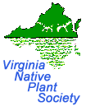 Coastal Plain Talk

Newsletter of the South Hampton Roads Chapter____________ _January/February 2014

Calendar of Events
Additional details online at www.sites/google.com/site/vanativeplantsociety/

Saturday, January 4th – Plant Sale Prep: Start orders, pick up supplies

Saturday, January 18th – Plant Sale Prep: Work on orders, visit nurseries & pick up plants

Thursday, January 23rd - Eric Gunderson, Landscaping with Native Plants at 7 PM in the Holly Room of Norfolk Botanical Garden. Our own SHR member will present to us ideas using native plants in the landscape. Eric is also the owner of Southern Branch Nursery in Suffolk, VA.

Friday, January 24th – Noah Strycker, Author & Photographer, Keynote Speaker for the Wildlife Festival at the Central Library, Virginia Beach

Thursday, January 30th – Set-up for booth for the Flower & Garden Expo 2014 at the Virginia Beach Convention Center, 19th Street, Virginia Beach. Volunteers needed for set-up of booth. Contact Amy Jones.

Friday, January 30 – Sunday, February 2nd – Flower & Garden Expo 2014, Virginia Beach Convention Center, 19th Street, Virginia Beach. Volunteers needed for shift work in booth. Contact Amy Jones.

Saturday, February 1st – Plant Sale Prep: Pick up plants & pot

Thursday, February 13th – Plant Sale Prep: Pick up plants & pot

Sunday, February 15th - Butterfly Society of Virginia presents a Panel Discussion, 2 PM in the Rose Garden Hall at the Norfolk Botanical Garden. Guest speaker will be Dr. Doug Tallamy, Author.

Saturday, February 22nd – Plant Sale Prep: Pick up plants & pot

Thursday, February 27th – Helen Hamilton, author of Wildflowers & Grasses of Virginia’s Coastal Plains at 7 PM in the Holly Room at the Norfolk Botanical Garden. Helen will sign her book which will be available for purchase at the meeting.

Saturday, March 1st – VNPS Annual Workshop

Saturday, March 8th – Plant Sale Prep: Pick up plants & pot

Tuesday, March 18th – Plant Sale Prep: Pick up plants & pot

Thursday, March 27th - Dr. Chris Ludwig Training on the Flora of Virginia at 7 PM in the TBA at the Norfolk Botanical Garden.

Saturday, March 29th – Plant Sale Prep: Pick up plants & pot

Friday, April 4th – Plant Sale Prep: Pick up plants & load

Saturday, April 5th - SHRC-VNPS PLANT SALE, 10 AM – 4 PM at the Francis Land House for the Gathering of the Guilds. 3131 Virginia Beach Blvd., Virginia Beach. No charge for admission.

Friday, April 11th – 12th – Tidewater Builders Association Home & Flower Show, Virginia Beach Convention Center, 19th Street, Virginia Beach

Friday, Saturday, April 20th & 21st – Hermitage Museum and Gardens Spring Plant Sale. Friday from 10 AM – 3 PM & Saturday 9 AM to 2 PM. 7637 North Shore Road, Norfolk. Some native plants will be available, including those for wetlands. Contact Yolima Carr at yc@thfm.org or (757) 423-2052 ext. 202 for information.

Thursday, April 24th- SHRC-VNPS Chapter Meeting, 7 PM in the Holly Room at Norfolk Botanical Garden. TBA.

Friday & Saturday April 27th & 28th - Chesapeake Master Gardener Plant Sale, 8 AM to 6 PM, Friday, 9 AM to NOON Saturday. Located in front of the Great Bridge Community Center. 212 Holt Dr., Chesapeake. For more information, contact the Chesapeake Extension Office at (757) 382-6348.

Friday, Saturday, May 10 & 11- SHRC VNPS PLANT SALE, 10:00 a.m. – 4:00 p.m., at the Norfolk Botanical Garden in conjunction with the Mother’s Day Weekend Event. 6700 Azalea Garden Road, Norfolk. Regular NBG admission rates apply to enter the garden. Additional information and details on our website.

President’s Message:

We have a busy next couple months coming up, and, it's already time for purchasing plants for the spring plant sale. Pat started poring over catalogs in December. Tyco is cutting blinds for labels. Some orders were placed and some nursery visits are in store. Please review the Calendar of Events because we tried to lay out a schedule that allowed members to participate during the week days and Saturdays. There is a job task for any one that wants to help even from the comfort of your home! We have sticker labels that need to be stuck onto mini-blind plant tags. So please try to lend a hand for our annual fundraiser.

Another proposed change to the plant sale after considering issues we had in the past and my desire to always improve our processes. Since the Butterfly Society starts their plant sale at 9 AM and we start our sale at 10 AM. It has caused confusion and aggravation from customers who are unaware they are jumping our boundary line as we set up prior to opening. Signs stating the start and end time could be placed along the waters’ edge. That hour difference may cause us to lose customers who do not want to wait or causes confusion among the customers. I propose we start our plant sale at the Frances Land House at 9 AM on April 6, 2014. I would like the Board to consider a vote on this.

Pre-Plant Sale Parties

Plant sale prep needs to be done ahead of our annual plant sales. Please check out the Calendar of Events so to see when we have scheduled what party for each type of event. We need to make labels, adhered the labels to blind tags already cut by Tyco for us. Any plugs or seedlings that need to be transplanted into pots will be done also. Once we have plants in the greenhouse then the plants will have to be watered regularly. If you would like to volunteer for the sale(s), please contact Pat Quinn at pat.quinn@cox.net or at 757-587-8935.

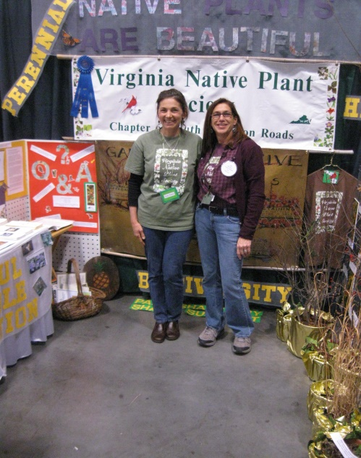
Gardens Galore: Natives Galore

The Flower & Garden Expo 2014 is January 31 – February 2, 2014 at the Virginia Beach Convention Center. That is also Superbowl Weekend football fans so please make time for both shows! We will set-up the booth Thursday afternoon, January 30th in Hall C from 3 PM to 6 PM.

We are requesting volunteers to work the booth in three hour shifts so we can cover our time from 10 AM to 7 PM on Friday and Saturday from 10 AM to 7 PM.

We need volunteers on Sunday, Feb. 2nd from 10 AM to 5 PM. If you are interested -in helping us set up, work a booth shift or tear down, please contact Amy Jones at amynally1@aol.com 757-392-5913 at or Beth Richardson at 757-574-5448 or bethrichardson@cox.net

Our Wildflower of the Year is Coral Honeysuckle - Lonicera sempervirens which is being illustrated by Amy as a poster for the booth. She is so talented! Thanks Amy.

We will have a double booth with sample plants and hopefully the Flora of Virginia display. Come out and join the fun!

Saturday, April 6, 2014  9AM – 3PM  Francis Land House  In conjunction with the  Butterfly Society of Virginia at the  Gathering of the Guilds  3131 Virginia Beach Blvd  Virginia Beach, VA | Friday & Saturday  May 10 & 11, 2014  10AM – 5PM  Norfolk Botanical Garden  In conjunction with  Mother’s Day Weekend Event  6700 Azalea Garden Road  Norfolk, VA  (Regular NBG admission rates apply)
Plant sale proceeds fund the many conservation, restoration and educational projects that the SHRC-VNPS supports.

